Software Requirements Specification

For

Play, Learn & Protect: Technology for Childhood & Youth

Version 1.0 approved
Prepared by Ibrahim Moataz,Ali Alaa,Aly waleed,yehia elbably,hamza bakr, Ibrahim Darwish,Youssef Abdelmalak , mazen gamal
GIU
6/12/2025

Table of Contents
Table of Contents ii
Revision History ii
1. Introduction 1
1.1 Purpose 1
1.2 Document Conventions 1
1.3 Intended Audience and Reading Suggestions 1
1.4 Product Scope 1
1.5 References 1
2. Overall Description 2
2.1 Product Perspective 2
2.2 Product Functions 2
2.3 User Classes and Characteristics 2
2.4 Operating Environment 2
2.5 Design and Implementation Constraints 2
2.6 User Documentation 2
2.7 Assumptions and Dependencies 3
3. External Interface Requirements 3
3.1 User Interfaces 3
3.2 Hardware Interfaces 3
3.3 Software Interfaces 3
3.4 Communications Interfaces 3
4. System Features 4
4.1 System Feature 1 4
4.2 System Feature 2 (and so on) 4
5. Other Nonfunctional Requirements 4
5.1 Performance Requirements 4
5.2 Safety Requirements 5
5.3 Security Requirements 5
5.4 Software Quality Attributes 5
5.5 Business Rules 5
6. Other Requirements 5
Appendix A: Glossary 5
Appendix B: Analysis Models 5
Appendix C: To Be Determined List 6

1.Introduction

1.1 Purpose
This Software Requirements Specification (SRS) documents the functional and non-functional requirements for the Play, Learn & Protect platform, designated as Version 1.0. This document defines the necessary features to create a culturally sensitive, multi-user software product aimed at improving childhood education, imagination, and digital safety within local contexts, specifically addressing the needs identified in the original project proposal. The scope of this SRS covers the entire system, encompassing the learning content delivery, the gamified user interface, and the protective monitoring subsystem.

  - Document Conventions
All detailed requirements are captured using the User Story or diagrams format.
All requirements documented in this initial SRS are considered High Priority for system delivery, unless explicitly stated otherwise.
Key terms and system names (e.g., Play, Learn & Protect, Child Monitoring Dashboard) are emphasized using bold text for clarity.
UML diagrams are used throughout the document to visually represent the system's structure and behavior.

  - Intended Audience and Reading Suggestions
This SRS is tailored for several groups:

Audience | Primary Interest & Focus | Suggested Reading Sequence
Developers/QA Team | Detailed functionality, technical constraints, and acceptance criteria. | Sections 1.0, 2.0, 2.4, 2.5, and the specific functional requirements in Section 3.0 (to be completed).
Project Managers/Sponsors | Product scope, overall design, user classes, and dependencies. | Sections 1.0, 1.4, 2.0 (especially 2.2 and 2.3).
Educational/Safety Consultants | Product functions, user characteristics, and the behavioral monitoring constraints. | Sections 2.2, 2.3, and all requirements related to learning and safety.
The most effective reading sequence for all audiences is to begin with the high-level context provided in Section 1.0 and 2.0 before diving into the granular details of the specific requirements in Section 3.0.

1.4 Product Scope
The Play, Learn & Protect software is a comprehensive digital platform whose primary purpose is to deliver high-quality and safe digital experiences to children and youth across three age brackets: (3-5), (6-8), and (9-12) years old.
The core objectives are:
- Impactful Learning: To use "serious games" to teach curriculum-based subjects .
- Creative Development: To teach imagination and social skills through collaborative, playful content.
- Digital Well-being: To proactively protect children by monitoring digital behavior (cyberbullying, screen time) and generating instructional safety alerts.
This platform directly supports the strategic goal of providing culturally relevant and modern educational tools, thereby serving as a foundational technology for childhood development in the local market.
1.5 References
Websites used for this SRS :
Cms , Draw.io

2- Overall Description

2.1 System Overview
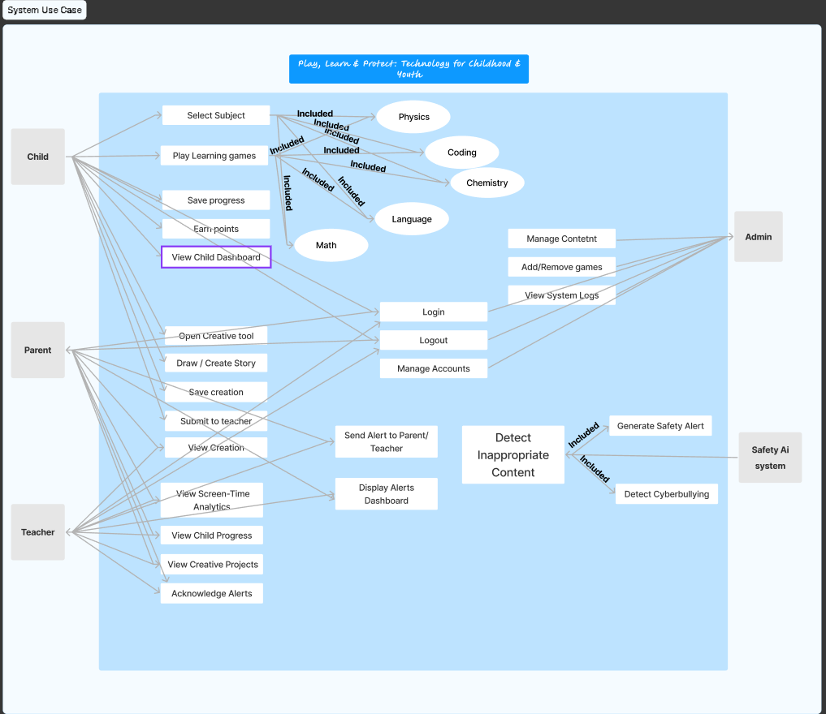

2.2 Product Perspective
The Play, Learn & Protect system is a new product. It is not a replacement for a any specific system , or a follow-on to any existing software. It operates as a singular, integrated platform with distinct subsystems that communicate internally:
- Core Content System (CCS): Manages game logic, learning modules, and the creative environment.
- User Interface Layer (UI): Provides the gamified dashboard for children and the analytical dashboards for parents/educators.
- Digital Protection Module (DPM): Handles data logging, behavioral analysis, and alert generation.
The system primarily interfaces with the following external entities: the Child, the Parent/Educator, and the secure cloud server used for data persistence and authentication.
2.3 Product Functions
The platform provides functionality across three main pillars:
- Learning & Play:
  - Allowing the Child to play curricula-based serious games (Math, Physics, Coding).
  - Allowing the Child to use a dedicated creative context module to apply learned knowledge.
  - Providing a gamified child dashboard with points, achievements, and real-time leaderboards.
- Protection & Safety:
  - Continuously logging and analyzing the Child's screen time, content accessed, and session frequency.
  - Running background algorithms to detect and flag online threats (e.g., cyberbullying , explicit content).
  - Generating proactive, teaching-focused safety alerts directly to the Child when a threat is identified.
- Monitoring & Feedback (Parent/Educator):
  - Providing secure, detailed monitoring dashboards to view digital behavior patterns.
  - Delivering immediate, actionable alerts to Parents/Educators regarding flagged behavior.
  - Allowing Parents/Educators to view the Child's learning progress, achievements, and creative output.

2.4 User Classes and Characteristics
The system has three primary user classes:
User Class | Importance | Characteristics
Child (3-12) | Most Important | Requires a highly visual, touch-friendly, intuitive interface. Divided into three sub-groups (3-5, 6-8, 9-12) with tailored complexity. Primarily interested in engagement and reward.
Parent/Guardian | Very Important | Technical proficiency varies. Requires clear, concise data visualization and easy-to-manage controls (e.g., setting screen limits). Sensitive to data privacy.
Educator/Teacher | Important | Requires summarized data for multiple students. Focused on curriculum alignment and group metrics.

2.5 Operating Environment
The software is designed for operation in a cross-platform, cloud-dependent environment:
- Client Devices: The interface must be fully responsive and functional across major operating systems and devices (iOS, Android, Windows) accessed via standard web browsers.
- Operating System/Browser: Latest releases of Chrome, Safari, and Firefox.

2.6 Design and Implementation Constraints
- Cultural Constraints: Content generation, asset design, and interface language (Arabic preferred) must adhere strictly to local cultural sensitivities and family values so that it makes no issues.
- Data Privacy: All data collection regarding the child's activity must comply with strict privacy policies, specifically limiting data logging only to what is necessary for.
- Performance: The serious games module must achieve a minimum user-perceived load time of under 3 seconds and maintain interactivity at all times as children can have low attention span.

2.7 User Documentation
The delivered software will include the following user documentation components:
- Integrated Tutorials (Child): Interactive, optional tutorials embedded within the serious games to explain rules, physics, and creative tool usage.
- Online Help Center (Parent/Educator): A comprehensive, searchable digital manual accessible via the monitoring dashboard detailing features, alert interpretation, and troubleshooting.
- "How-To" Video Guides: Short video tutorials demonstrating key parental monitoring tasks (e.g., setting screen limits, viewing progress).

2.8 Assumptions and Dependencies
Assumptions
- Provided Assets: curriculum content outlines and culturally relevant artistic assets (e.g., character designs, historical elements) will be provided by subject Teachers.
- Educational Validity: Content is assumed to be educationally sound and age-appropriate upon initial design and review by the project's educational consultant.
Dependencies
- Firebase Authentication & Firestore: The entire system relies on the core functionality of Firebase for user management and real-time data storage.
- External API Access: Potential future dependencies on external APIs (e.g., Gemini API for advanced content or natural language processing) for enhanced safety or learning features.

3- External Interface Requirements

3.1 User Interfaces
The system shall provide child-friendly, intuitive, and gamified interfaces accessible to children, teachers, and parents. Key interface features include:
- Dashboards for monitoring progress, achievements, and points.
- Interactive modules for learning (math, science, language, coding).
- Visual feedback for earned awards, leaderboards, and competitions.
- Notifications and alerts for digital safety incidents.
- Multi-language support including Arabic and English.

3.2 Hardware Interfaces
The system shall support interaction with standard consumer devices, including:
- Tablets and smartphones running Android or iOS.
- Desktop/laptop computers running Windows, macOS, or Linux.
- Input devices such as keyboard, mouse, and touchscreens.
- Internet connectivity for real-time data synchronization and updates.

3.3 Software Interfaces
The system shall interface with the following software components:
- Web browsers (Chrome, Edge, Safari) for web-based access.
- Mobile OS SDKs for Android and iOS apps.
- Backend services for data storage, analytics, and user management.
- APIs for third-party learning content integration (optional).

3.4 Communications Interfaces
The system shall utilize standard communication protocols to ensure secure and efficient data transfer:
- HTTPS/REST APIs for client-server communication.
- WebSocket protocols for real-time notifications and alerts.
- Email and push notifications for parental alerts.
- Secure data transmission following encryption standards (TLS 1.2 or higher).

4- System Features

This section organizes the detailed functional requirements by the major services, or features, the Play, Learn & Protect platform offers.
4.1 Digital Protection Module (DPM)
This feature encompasses all capabilities related to monitoring the child's online activity, identifying potential risks, and generating safety alerts for both the child and the supervising adult.
4.1.1 Description and Priority
The DPM is the core safety component of the system. It operates passively in the background, logging activity and applying proprietary algorithms to detect digital threats, including but not limited to cyberbullying, exposure to inappropriate content, and patterns indicative of excessive gaming. The primary goal is to educate the child on safe digital behavior, rather than simply block content.
- Priority: High (This feature is central to the "Protect" mandate of the project and addresses a critical societal need.)
- Risk: High (False positive alerts could erode user trust; algorithms require extensive tuning and validation.)
4.1.2 Stimulus/Response Sequences
Stimulus (User Action/System Event) | Response (System Behavior)
Child enters text into the in-game chat/comment section containing a flagged keyword (e.g., bullying language). | The DPM processes the text, flags the interaction, and initiates the Alert Generation sequence.
Child session duration exceeds the pre-set parental time limit by 15 minutes. | The DPM triggers a soft, in-game notification to the child asking them to take a break, and updates the Parent/Educator Dashboard.
Parent/Educator logs into the monitoring dashboard. | The system retrieves and displays the child’s aggregated digital activity data (screen time, content history) in real-time charts.
Parent/Educator clicks the "Acknowledge" button on a safety alert notification. | The system records the acknowledgment timestamp and moves the alert to the history log, removing it from the active alerts list.
4.1.3 Functional Requirements
The following functional requirements detail the capabilities for the Digital Protection Module:
REQ-DPM-1: Real-Time Activity Logging
The system shall continuously and non-intrusively log the Child's session start/end times, content accessed (game title/module name), and total time spent in each session.
REQ-DPM-2: Threat Detection Algorithm
The system shall employ a language processing algorithm to analyze user-generated text (e.g., comments, chat) for keywords or patterns associated with cyberbullying, harassment, or explicit content.
Use Case Diagram for Digital Protection Module
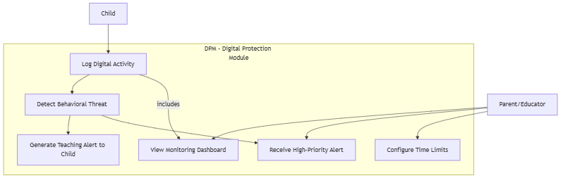

4.1.4 Gamified Dashboard (REQ-UI-1)
Description and Priority
The Gamified Dashboard provides a child-friendly interface to display achievements, points, leaderboards, and awards in real-time. It is designed to motivate engagement and learning by incorporating game-like rewards and progress indicators. This feature enhances the overall user experience by encouraging continued participation.
Priority: High (Encourages learning through engagement; central to “Play & Learn” mandate)
Risk: Medium (Poorly designed dashboards may confuse children or reduce motivation)
Stimulus/Response Sequences
Stimulus (User Action/System Event) | Response (System Behavior)
Child completes a learning module successfully | The system updates points, achievements, and awards on the dashboard immediately.
Child opens the dashboard | The system displays real-time stats: points, leaderboard position, badges, and awards earned.
Parent/educator logs into dashboard view | The system presents the child’s progress, achievements, and leaderboard rankings in a visually clear manner.
Child earns a new badge or unlocks an award | The system triggers an animated notification on the dashboard to celebrate achievement.
Functional Requirements
- REQ-UI-1: The system shall provide a child-friendly dashboard that displays achievements, points, leaderboards, and awards in real-time to motivate engagement and learning.
Activity Diagram
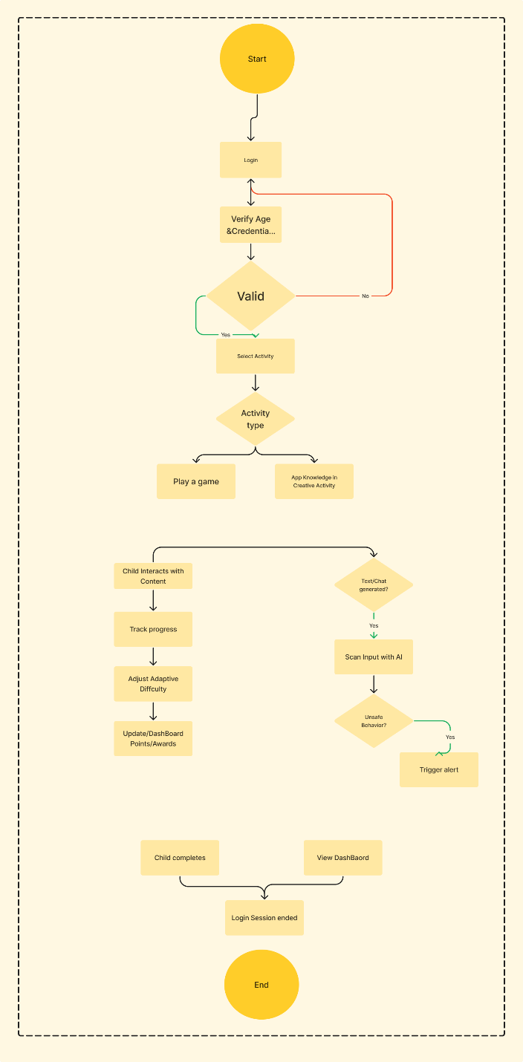

4.1.5 Curriculum-Based Learning Modules (REQ-LRN-1)
Description and Priority
These modules offer interactive, curriculum-based learning experiences in subjects such as math, science, language, and coding. The system tracks the child’s progress and adapts difficulty based on performance to ensure effective learning outcomes.
Priority: High (Core component of the “Learn” mandate)
Risk: Medium (Adaptive algorithms may misjudge difficulty or progression without proper tuning)
Stimulus/Response Sequences
Stimulus (User Action/System Event) | Response (System Behavior)
Child starts a learning module | The system presents interactive content with adaptive difficulty based on prior performance.
Child answers a question correctly | The system updates progress tracking, awards points, and may adjust difficulty upwards.
Child answers a question incorrectly | The system provides hints, feedback, and adjusts difficulty or review material.
Parent/educator views module progress | The system displays completion status, scores, and adaptive recommendations in a dashboard view.
Functional Requirements
- REQ-LRN-1: The system shall offer interactive learning modules covering subjects such as math, science, language, and coding, with progress tracking and adaptive difficulty based on the child’s performance.
Sequence Diagram
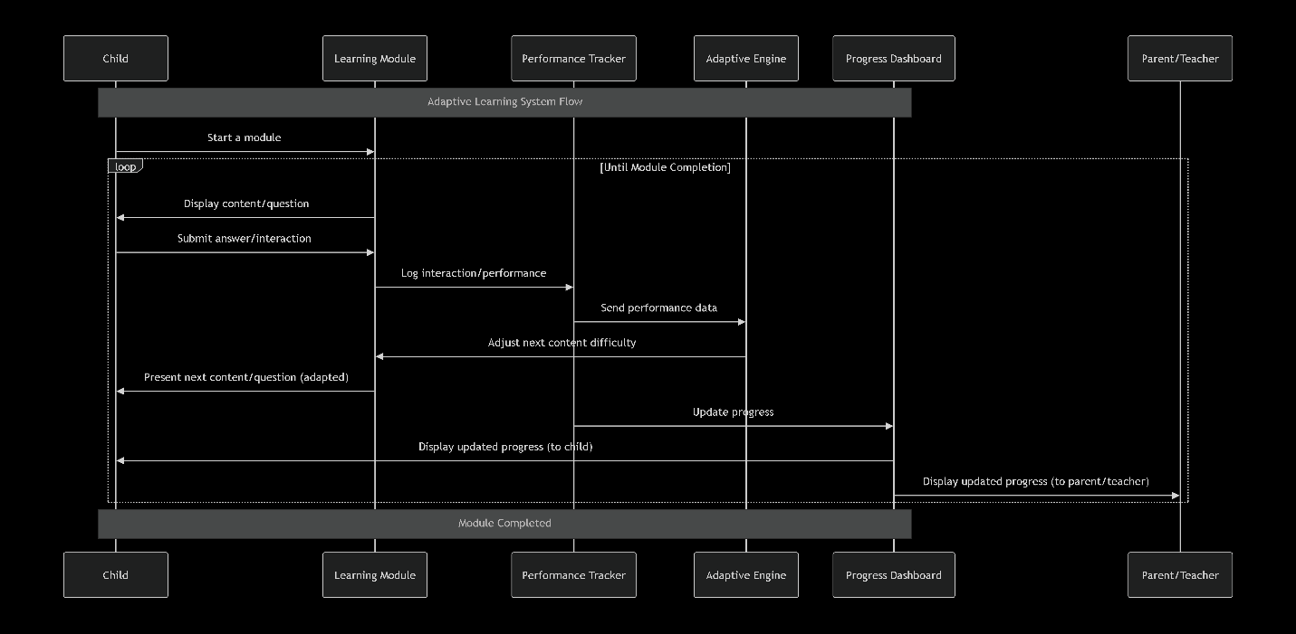

4.1.6 Creative Application Studio (REQ-CRE-1)
Description and Priority
This feature addresses the project requirement that children must be able to apply knowledge learned in a creative context. It allows users to transition from "serious games" to a "studio" mode where they can use open-ended tools (drawing, building, storytelling) related to the curriculum (e.g., using physics concepts to build a structure). This fosters imagination as required by the proposal.
Priority: High (Essential for distinguishing the platform from simple rote-learning apps and fulfilling the "Play" mandate).
Risk: High (Complexity in creating open-ended tools that are intuitive for 3–5-year-olds).
Stimulus/Response Sequences:
Stimulus (User Action/System Event) | Response (System Behavior)
Child selects "Create Mode" after a Physics lesson | The system loads the Creative Studio with specific tools unlocked (e.g., gravity, blocks) relevant to the lesson
Child attempts to save their creative project | The system validates the content, saves the project to the user profile, and awards "Creativity Points"
Child selects "Share with Teacher" | The system changes the project state to "Submitted" and notifies the linked Educator account
Child attempts to use a tool they haven't unlocked yet | The system displays a prompt encouraging the child to play specific learning games to unlock the tool
Functional Requirements
REQ-CRE-1: The system shall provide a Creative Application Studio that allows children to utilize digital tools to create artifacts (stories, drawings, structures) applying concepts learned in curriculum modules, with capabilities to save, edit, and share work with educators.

WRSPM Model
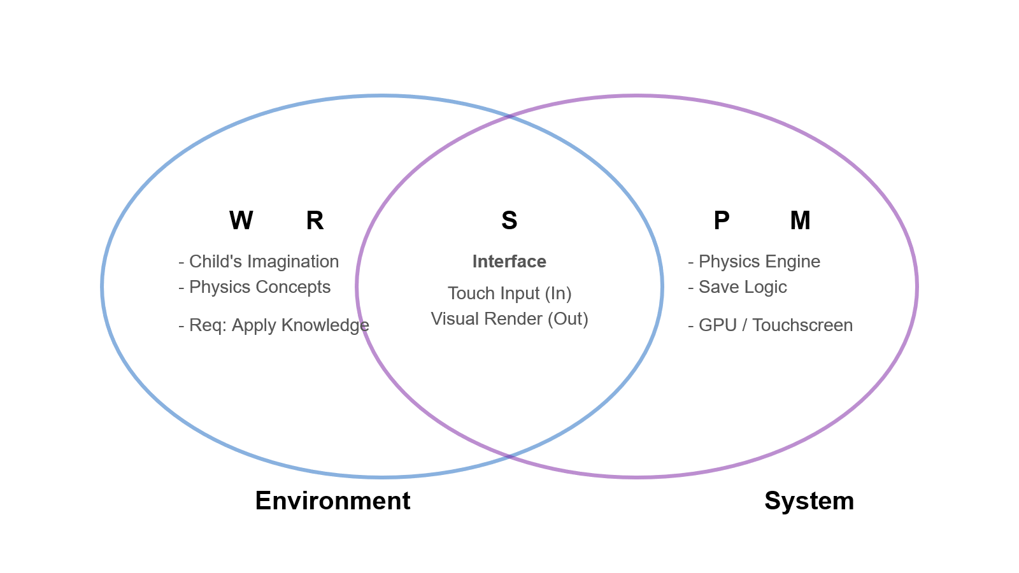
4.1.7 Parental Analytics & Visualization (REQ-ANL-1)
Description and Priority
While the Digital Protection Module (4.1) handles logging and alerts, this feature specifically addresses the requirement for Dashboards that visualize time spent, types of content accessed, and frequency of sessions. This feature processes raw logs into readable, graphical insights for parents and educators to observe screen-time patterns.
Priority: Medium (Critical for the "Protect" aspect, specifically for adult supervision, though the system can function without the visualization layer initially).
Risk: Low (Standard data visualization task, though data privacy regarding what specific details are shown to teachers vs. parents must be handled carefully).

Stimulus/Response Sequences:
Stimulus (User Action/System Event) | Response (System Behavior)
Parent selects the "Screen Time" tab on the dashboard | The system queries the database and renders a bar chart showing daily usage hours over the last 7 days
Educator filters the class view by "At-Risk Behavior" | The system identifies students with flagged screen-time patterns and highlights them in the list
Parent clicks on a specific session in the history log | The system expands the view to show the specific games played and learning objectives covered during that session
A weekly cycle concludes (e.g., Sunday night) | The system automatically generates a "Weekly Summary" report and pushes a notification to the Parent
Functional Requirements
REQ-ANL-1: The system shall generate visual analytics dashboards for Parents and Educators that display aggregated data regarding screen time, session frequency, and content categorization, allowing for date-range filtering and trend analysis.
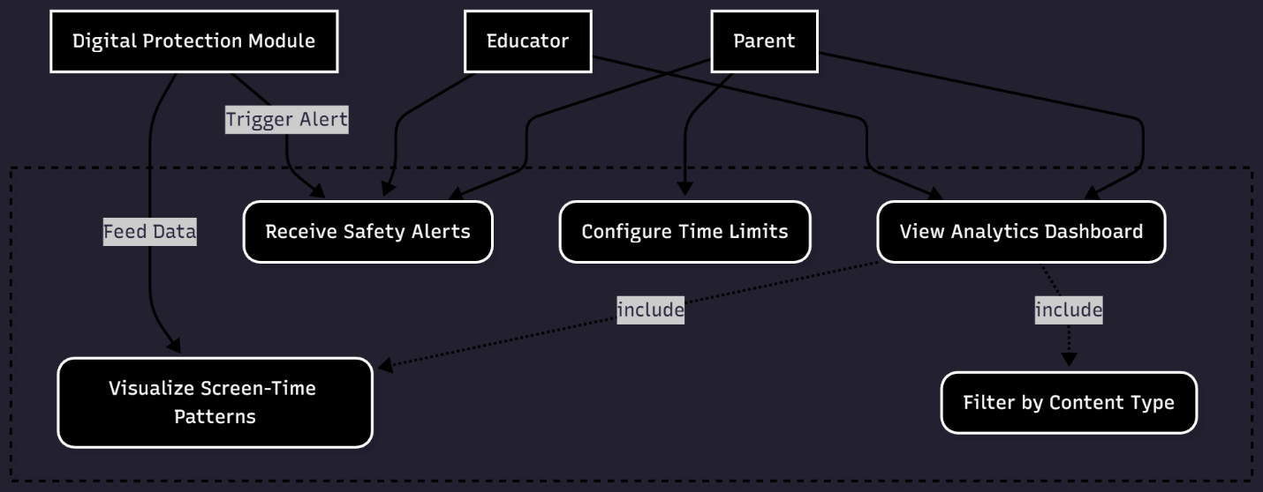
Use Case Diagram

